Humanitarian China’s ZOOM account shut down after Conference Commemorating 31st anniversary of Tiananmen Massacre.

On May 31st, Humanitarian China held the first ever ZOOM conference to commemorate the 31st anniversary of the Tiananmen Massacre. On June 7th, Around 10 PM EST, the ZOOM account used for this conference displayed a message that it had been shut down, and repeated logins failed. ZOOM has not responded to our requests for an explanation.

5月31日，人道中国举行了首次纪念天安门大屠杀31周年的ZOOM会议。 6月7日，美国东部时间晚上10点左右，此会议的ZOOM帐户显示一条消息表明该帐户已被关闭，并且重复登录失败。 ZOOM没有回应我们的解释要求。

The Conference represented many of the most important groups of the 1989 pro-democracy Movement and Tiananmen Massacre. More than 250 people worldwide joined the conference on ZOOM, while more than 4000 streamed through Social Media. A significant proportion of attendees were from China. Our conference provided many the opportunity to connect with activists abroad for the first time. As the most comprehensive Tiananmen conference of the last 31 years, the event was announced and reported by many news outlets.

此次会议代表了1989年民主运动和天安门大屠杀集体记忆最重要的团体。全世界250多人参加了ZOOM会议，4000多人利用社交媒体参加。 很多参加者来自中国。对于国内参加者，会议提供了第一次机会与国维权人士联系。会议作为过去31年来最全面的天安门纪念活动，收到许多新闻媒体都宣布并报道了该活动。

Speakers included the Tiananmen Mothers, workers severely punished for resisting the butchering troops, organizers of the Hong Kong Candlelight Vigil, writers and scholars, as well as former student leaders. Prevented by police from reporting live, most speakers from China sent pre recorded messages. Dong Shengkun, who priorly spent 17 years imprisoned by the Chinese Government, was detained for 5 days to prevent him from attending the conference live.

演讲者包括天安门母亲，因抵抗屠杀部队而受到严厉惩罚的工人，香港烛光守夜组织者，作家和学者和天安门学生领袖。 来自中国的大多数演讲者发送了预先录制的信息，因为他们被警方阻止实时与会。 董胜坤，被中共入狱十七年的北京抗暴工人代表，被带走5天以阻止他参加会议，会议上只能播放他事先录制的视频。

We are outraged by this act from ZOOM, a U.S company. Simultaneous to our censoring, thousands in relation to the Tiananmen Commemoration and Free Hong Kong Movements were silenced within China both online and through in person detainments. The ZOOM accounts of Wang Dan and the Hong Kong Alliance were also shut down. Another commemoration event encouraging dialogue on the Massacre was attacked twice by hackers, preventing viewers from logging in.

我们对ZOOM，一个美国公司，感到愤怒。 在ZOOM对我们进行审查的同时，中国当局成千上万对六四屠杀和香港民主运动的消息严蜜监控删除，很多人被以不同方式监禁，阻止他们纪念六四。 香港支联会的ZOOM帐户也被关闭，对话中国组织的六四纪念活动也两次被黑客攻击，无法登入。

As the most commercially popular meeting software worldwide, ZOOM is essential as an unbanned outreach to Chinese audiences remembering and commemorating Tiananmen Massacre during the Coronavirus Pandemic.

It seems possible ZOOM acted on pressure from the CCP to shut down our account. If so, ZOOM is complicit in erasing the memories of the Tiananmen Massacre in collaboration with an authoritarian government.

作为全球最通用的会议软件，尤其在冠状病毒大流行之中，ZOOM对于纪念天安门大屠杀的中国观众来说是至关重要的。

ZOOM似乎在中共的压力下采取行动关闭了我们的帐户。 如果是这样，ZOOM与专制政府合作，试图抹去对天安门大屠杀的记忆。

Humanitarian China demands an explanation of why our account was shut down, we will pursue other channels to protect our rights.

Screenshots enclosed of message detailing account closed before 10PM June 7th

人道中国要求解释为什么我们的帐户被关闭，并保留追究责任的权利。

随附的消息详细信息帐户的屏幕截图在6月7日晚上10点之前关闭

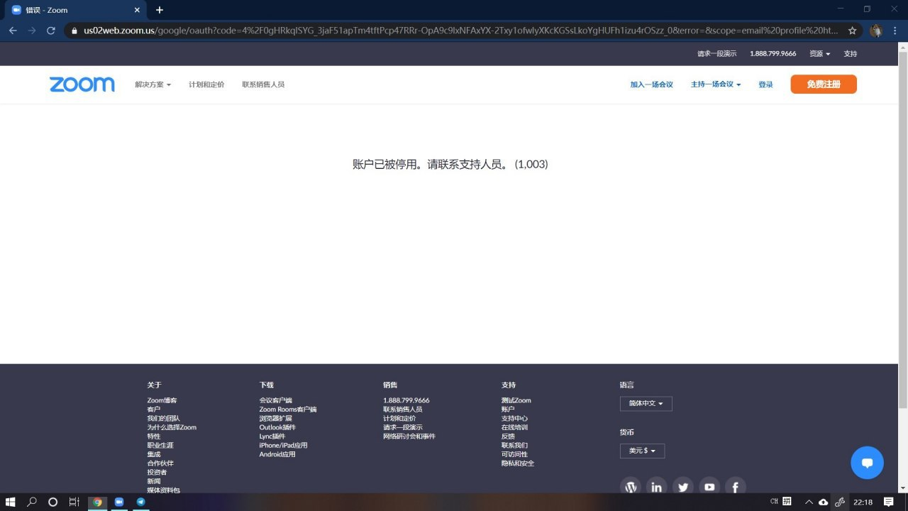

Payment confirmation May 25 付款信息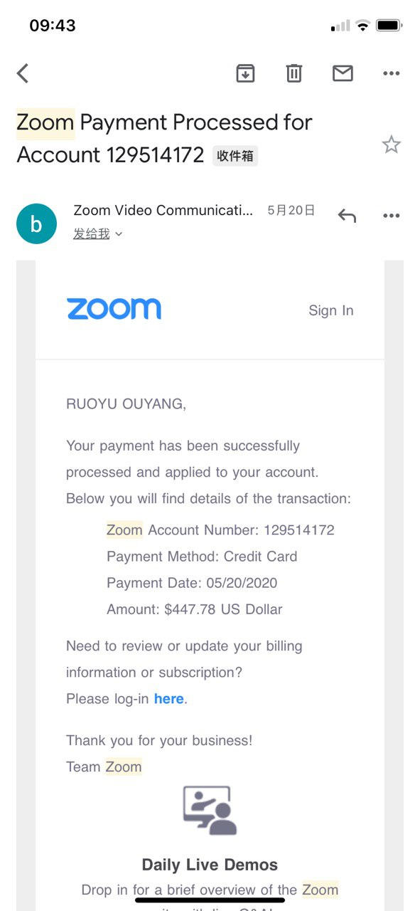

Announcement of the conference with full list of speakers

<http://minzhuzhongguo.org/MainArtShow.aspx?AID=105426>

以上链接是发表在民主中国杂志的会议通知，有所有讲员名单。

Posters with conference ID and password

显示会议账号，密码的会议通知

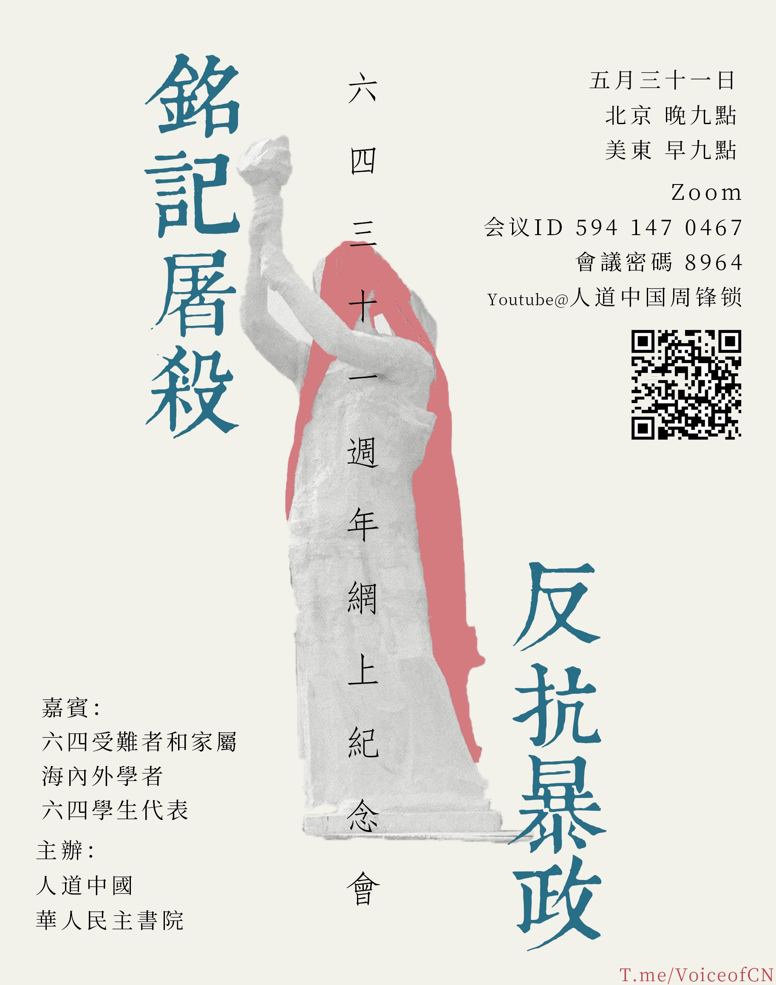

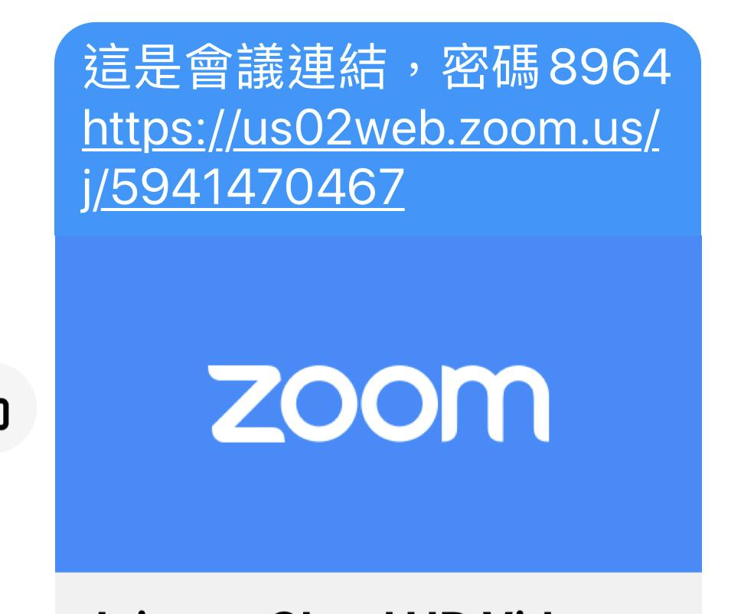

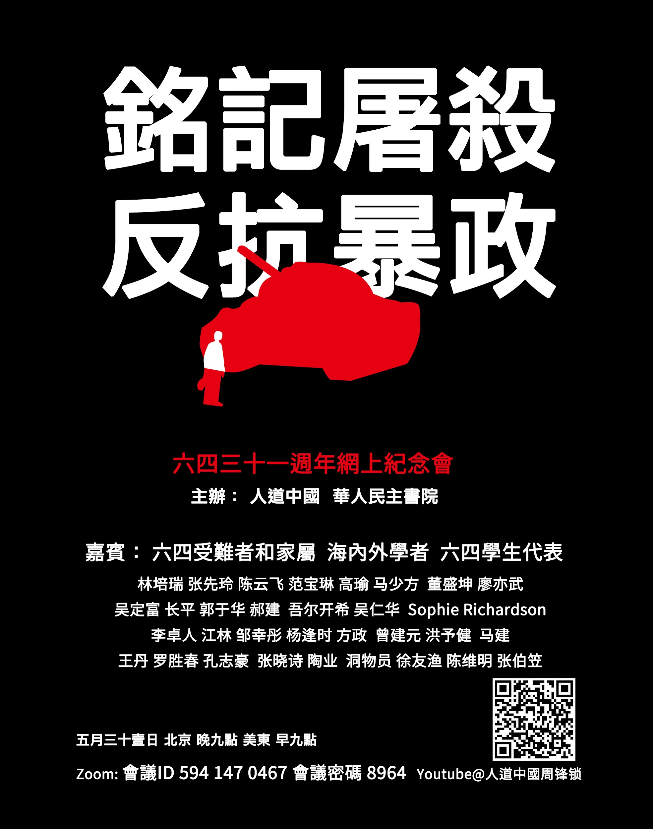

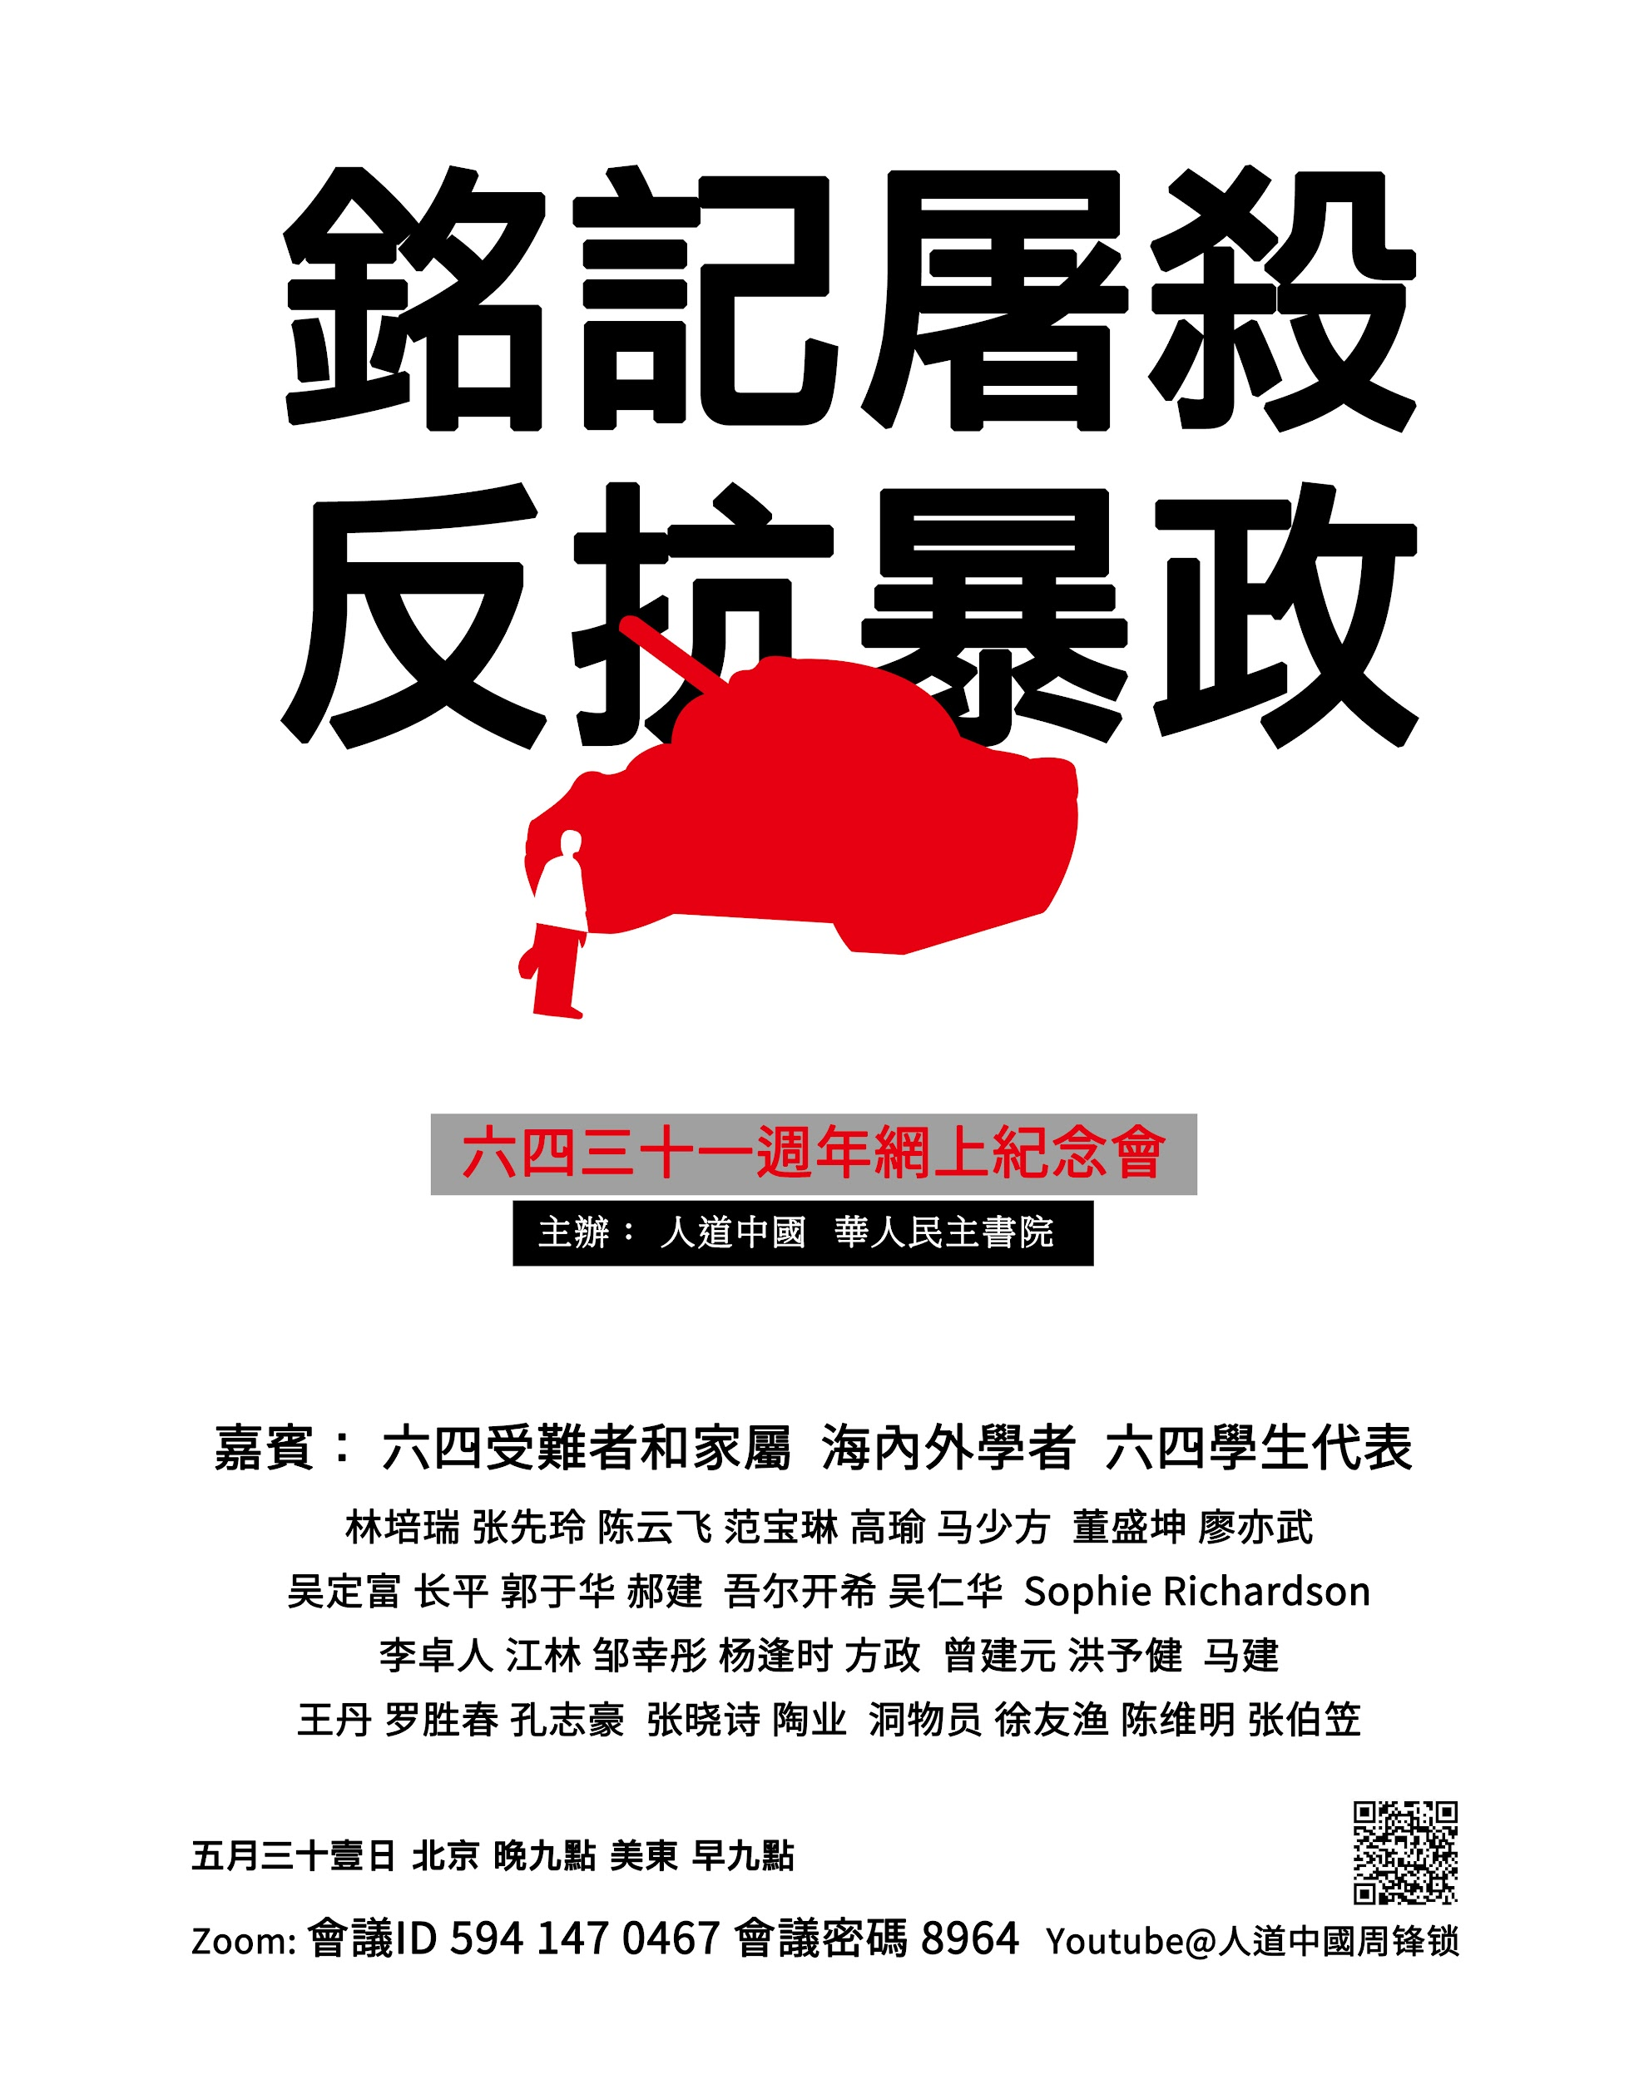

Zhang Xianling,co founder of the Tiananmen Mothers, giving her prerecorded message, this is the most powerful 3 minutes of testimony on Tiananmen Massacre

<https://www.youtube.com/watch?v=NGjQA6RjsiY>

以上链接是天安门母亲群体共同发起人张先玲女士的视频见证，描述了中共国军队的残暴嗜血以及直到今天受难者群体面临的迫害

Dong Shengkun, representative of the “Rioters”, Beijing citizen who tried stop the marching killing troops. He was sentenced to life in prison

[https://www.youtube.com/watch?v=Tja2DgXtYXA](https://www.youtube.com/watch?v=Tja2DgXtYXA&feature=share)

以上链接是北京六四屠杀后抗暴市民代表董盛坤，他后来入狱17年。

full live stream of the meeting <https://youtu.be/lPzh3K6C6lI>

Other videos all in this channel <https://www.youtube.com/channel/UC5oi0zvlTYjR0c1rMNDj0Eg>

以上是会议全程网上直播的视频。

ZOOM shut down account used by Hong Kong Alliance ,Statement of Cheuk Yen Lee, Chairman of Hong Kong Alliance, <https://www.facebook.com/1360002390/posts/10222496526826170/?d=n>以上链接是香港支联 李卓人先生发布的账号被封消息.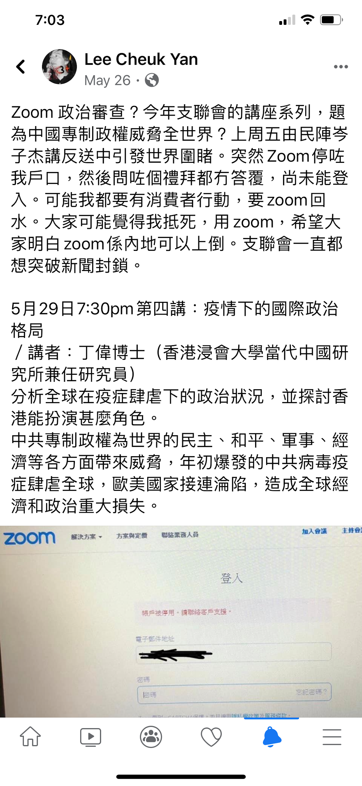

Statement of Wang Dan on ZOOM blocking Tiananmen Commemoration

<https://www.facebook.com/105759983026/posts/10157323963948027/?d=n>

王丹关于Zoom网络会议被攻击的声明

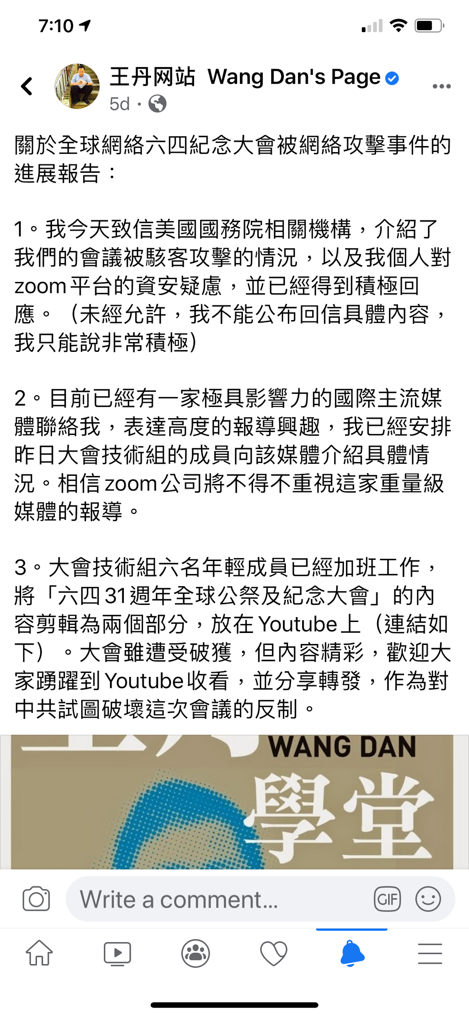

<https://www.facebook.com/permalink.php?story_fbid=10157322383428027&id=105759983026>